Problem No: 3

Problem Statement: Generate and plot sine and cosine waves in separate subplots using MATLAB.

Codes:
clc; clear; close all;
A = 1; f = 5; t = 0:0.001:1;
y1 = A * sin(2pift); y2 = A * cos(2pift);
figure;
% First subplot (Top)
subplot(2, 1, 1); plot(t, y1); grid on; title('Sine Wave'); xlabel('Time (s)'); ylabel('Amplitude');
% Second subplot (Bottom)
subplot(2, 1, 2); plot(t, y2); grid on; title('Cosine Wave'); xlabel('Time (s)'); ylabel('Amplitude');

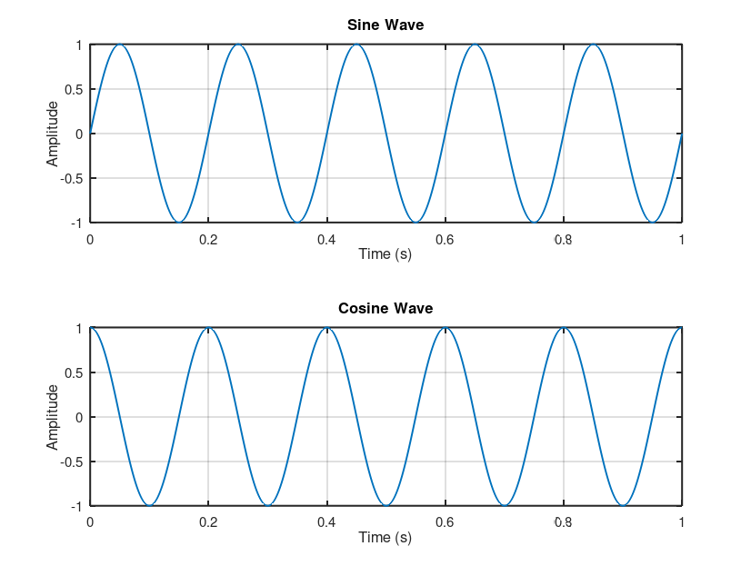
Output:

